Matthew Hoffman

CpE 403 – Advanced Embedded Systems

Lab 6

# Task 1:

Task 1 wanted the SW1 and SW2 to be able to control the PWM of the LED at PF1. SW1 would lower it until it hit 10% duty cycle while SW2 would increase the PWM until it hit 90% duty cycle.

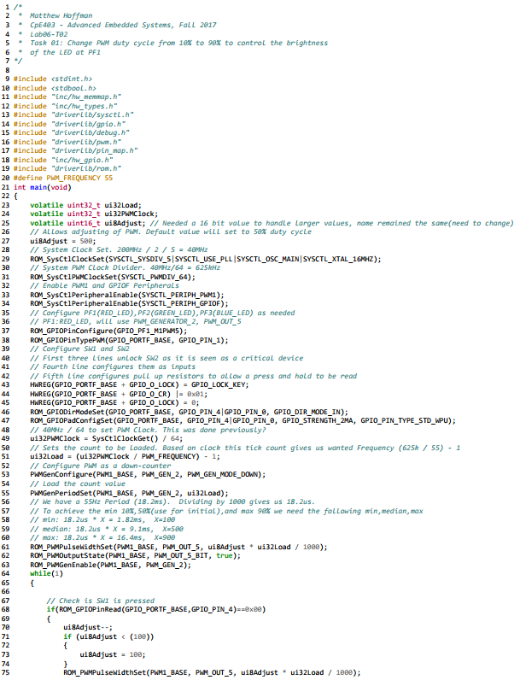 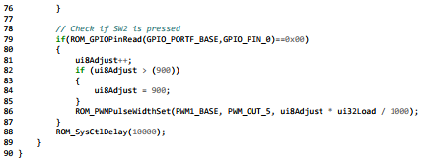

Figure 1. Lab06-T01 Source Code

# Task 2:

Task 2 asked the PWM cycle from 10% to 90% to control the brightness of all three LEDs at PF1, PF2, and PF3 using three nested “for loops.” By using nested for loops, one color tends to dominate as it is continuously varying from 10% to 90% while the others are slowly increasing/decreasing due to the inherit nature of the nest.